

Task 4 – Pass Submission

Student Number: 103181157
Student Name: Nguyen Nam Tung

Pass 4a
Paste your screen capture(s) for this task here.
CAMPAIGN (CampaignCode, CampaignTitle)
Primary Key (CampaignCode)

PLAYER (Pid, PName, Gender, CampaignCode)
Primary Key (Pid)
Foreign Key (CampaignCode) references CAMPAIGN

Pass 4b
Paste your screen capture(s) for this task here.
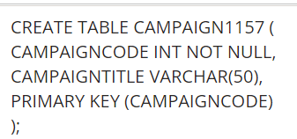
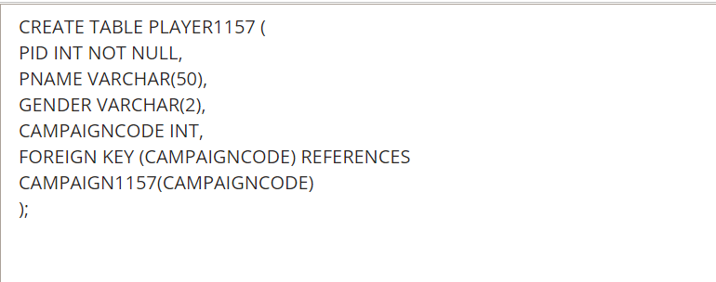
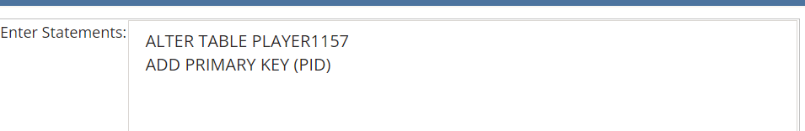
(I forgot to add primary key for the player table in the first time so I had to do this query)

Pass 4c
Paste your screen capture(s) for this task here.
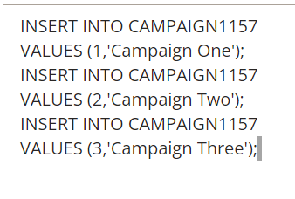
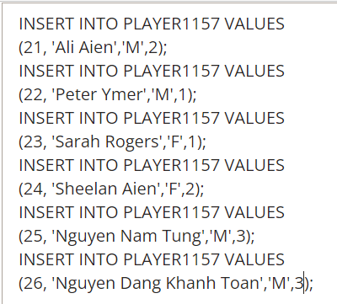

Pass 4d
Paste your screen capture(s) for this task here.
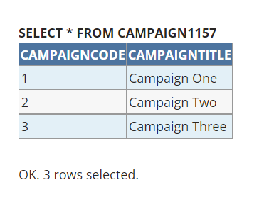
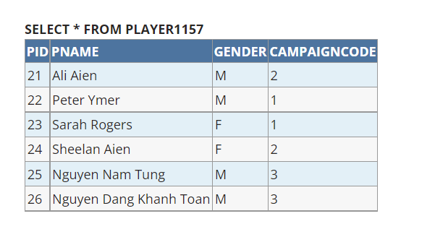

Pass 4e
Paste your screen capture(s) for this task here.
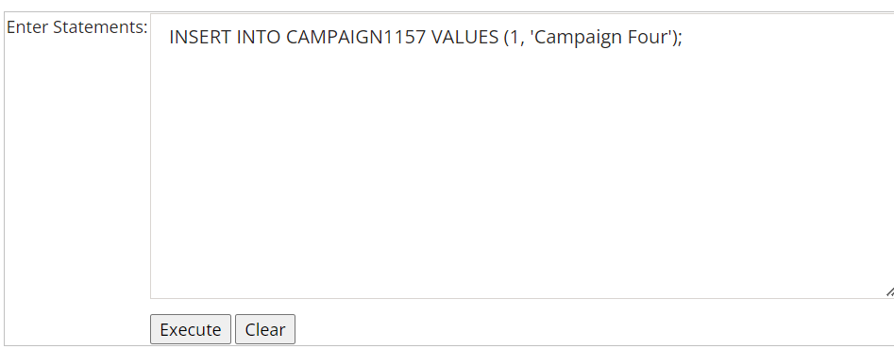
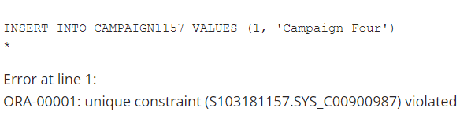
The query fails because primary key for each record is unique, 1 has existed, so there cannot be 1 again.
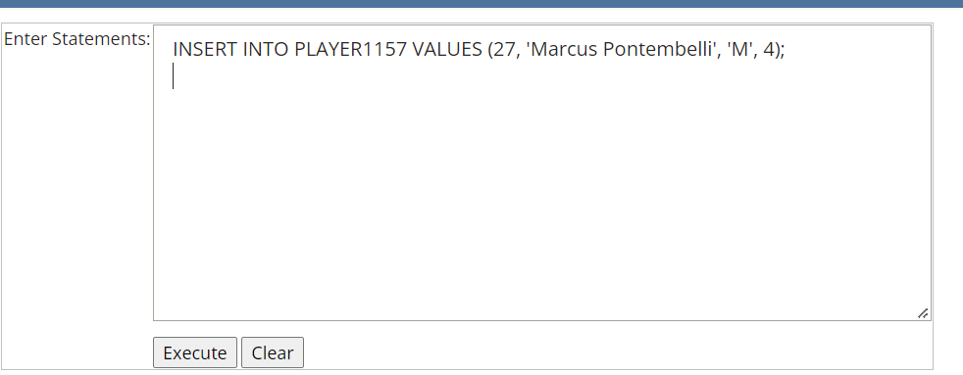
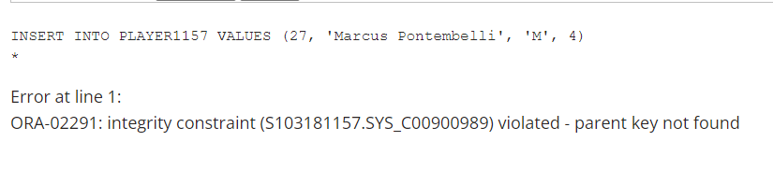
The query fails because foreign key of the player table is the primary key of the campaign table, but there is no primary key for 4, so this foreign key cannot exist.
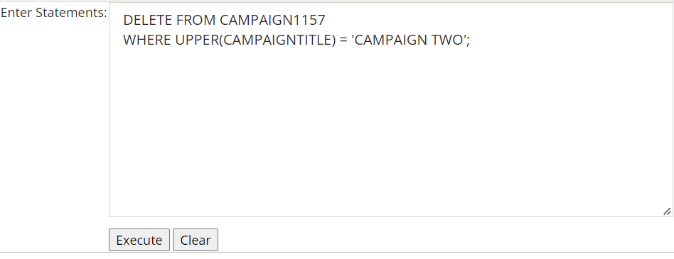
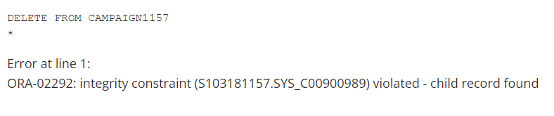
The query fails because I try to delete a record in the campaign table with the primary key campaign code is referenced to the foreign key of the player table. The records using the foreign key exist, so it can be deleted.

Pass 4f
Paste your screen capture(s) for this task here.
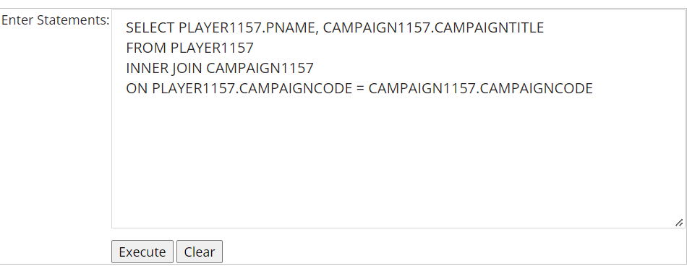
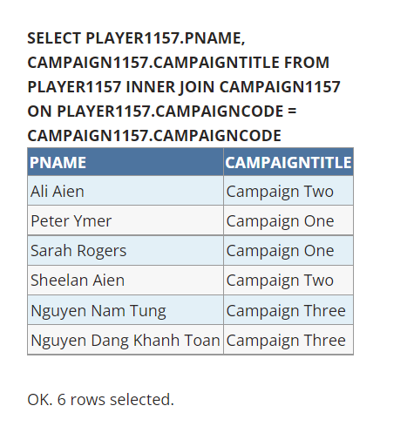

Pass 4g
Paste your screen capture(s) for this task here.
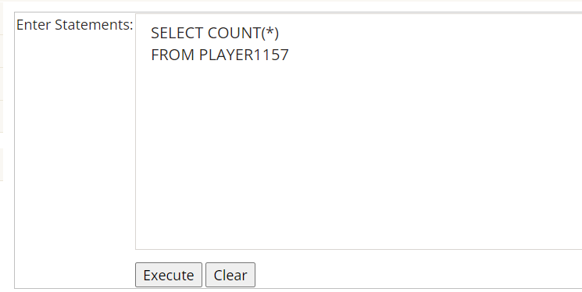
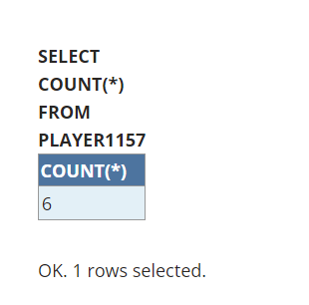
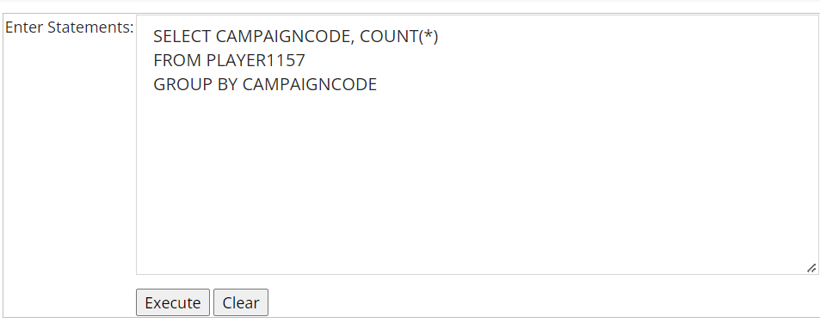
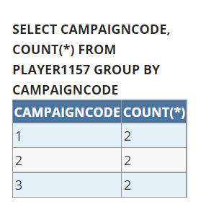

Pass 4h
Paste your screen capture(s) for this task here.
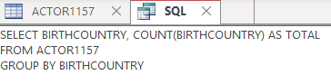
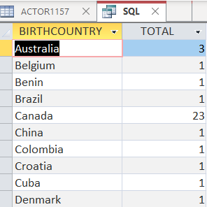

Pass 4i
Paste your screen capture(s) for this task here.
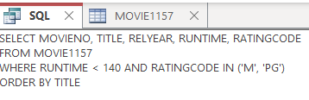
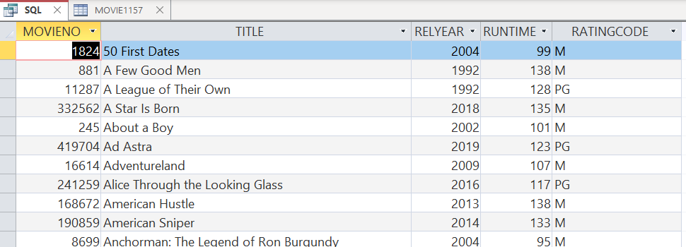
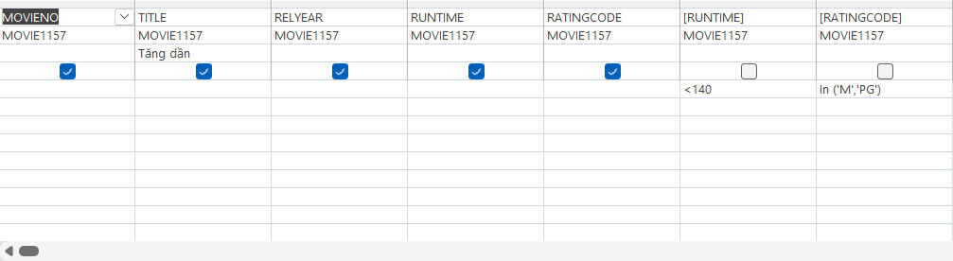

Pass 4j
Paste your screen capture(s) for this task here.
<Below>
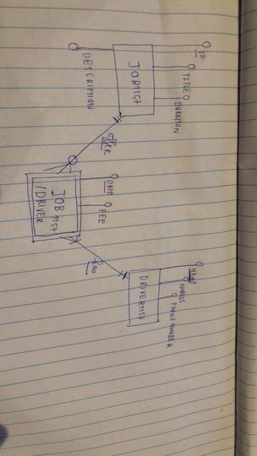
Relational Schema + Test Data
JOB1157(JOBID, TITLE, DURATION, DESCRIPTION)
PK (JOBID)
JOBID | TITLE | DURATION | DESCRIPTION
#47 | Part-time | 1 hour | This delivery job is suitable for applicants living in CBD  No experience required
#48 | Full-time | 2 hours | 3-year truck driving experience required

DRIVER1157(NAME, ADDRESS, PHONENUMBER)
PK (PHONENUMBER)
NAME | ADDRESS | PHONENUMBER
Tung Nguyen Nam | 1 Elizabeth Street, Melbourne VIC 3000 | 0313133232
Betty Baker | 132 Collins Street, Melbourne  VIC 3000 | 093280434

JOB/DRIVER1157(PHONENUMBER, JOBID, DATE, FEE)
PK (PHONENUMBER, JOBID, DATE)
FK (PHONENUMBER, JOBID) REFERENCES DRIVER1157, JOB1157
PHONENUMBER | JOBID | DATE | FEE
0313133232 | #47 | 04/12/2022 | $50
093280434 | #48 | 12/12/2022 | $60

Pass 4k
Paste your screen capture(s) for this task here.
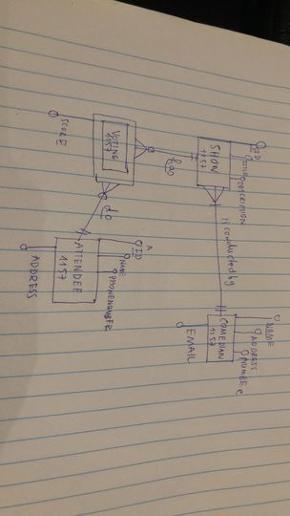
Relational Schema + Test Data
SHOW1157(SID, TITLE, DESCRIPTION, NAME)
PK(SID)
FK(PHONENUMBER) REFERENCE COMEDIAN1157
SID | TITLE | DESCRIPTION | PHONENUMBER
123 | Disappearing in the air! | This show is a recreation of the 1990 show | 043434434
124 | Hello world | This show offers a lot of valuable prizes | 0433434222

COMEDIAN1157(NAME, ADDRESS, PHONENUMBER, EMAIL)
PK(PHONENUMBER)
NAME | ADDRESS | PHONENUMBER | EMAIL
Tung Nguyen | 12 Collin Street, Melbourne CBD | 043434434 | gungwre123@gmail.com
Louis Vuitton | 24 Wakefield Street, Hawthorn | 0433434222 | Fdfefeff323@gmail.com

ATTENDEE1157(AID, NAME, PHONENUMBER, ADDRESS)
PK(AID)
AID | NAME | PHONENUMBER | ADDRESS
1 | Ngoc Tam | 03248320483 | 33 Mackenzie Street, Melbourne CBD
2 | Que Anh | 0424242443 | 26 Swanston Street, Melbourne CBD

VOTING1157(SID, AID, SCORE)
PK (SID, AID)
FK (SID, AID) REFERENCE SHOW1157, ATTENDE1157
SID | AID | SCORE
123 | 1 | 10
124 | 1 | 9

